New exhibition asks Is there space for Empathy?
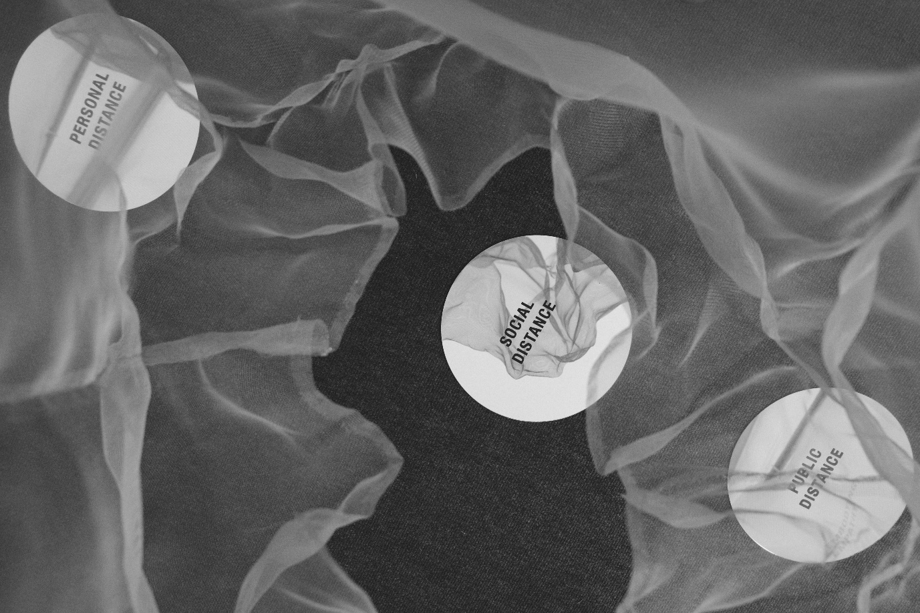
Embodying Empathy, image © LIFT, Photo Ingrid Guyon

Exhibition: 21 May – 8 August 2021
Private view: Thurs 20 May, 6-9pm

Is there Space for Empathy? How can we re-learn to be physically close again? These are just some of the questions empathy artist Enni-Kukka Tuomala will ask in her first UK solo exhibition at east London’s Nunnery Gallery.

Finnish artist and designer Tuomala has a vision to transform empathy from an individual feeling to a collective and radical power, something she has been doing globally everywhere from Tokyo to South Africa. Since 2018 she has been working with the Finnish Parliament to bring empathy into politics, and she has created empathy commissions for the likes of the BBC, Greater London Authority, LIFT and Bath University.

Tuomala’s first UK solo exhibition will create an experience of empathy, exploring what empathy means in 2021, in post-Brexit, post-Covid, post-colonial Britain. Through space, perspective, form and audience interaction, the show will examine what role empathy should play in helping us re-enter public life as we re-discover physical closeness with each other. Building on years of explorations into interpersonal distance and the spaces between people, Tuomala highlights both the visible and invisible distances between us, aiming to understand how they impact our abilities to meaningfully connect with one another.

Enni-Kukka Tuomala has said:
“Empathy is often thought of as an abstract concept and an intangible emotion. By working with empathy as a material as well as an intended outcome, by making it visible and giving it physical form and texture, I present empathy as concrete and tangible, and invite people to literally step inside it to be immersed in different perspectives.”

Sophie Hill, Director of Arts & Events, Bow Arts, has said:
“I can’t wait to see how Tuomala will transform our gallery with a visual exploration of empathy, creating an installation that will help visitors understand how the pandemic has affected our sense of space, closeness and touch.

Inviting our audiences back to experience a physical installation of empathy after many months of feeling apart, feels incredibly special.”

The exhibition follows Tuomala opening the first ever Empathy HQ, a dedicated space for empathy, acting both as Tuomala’s studio, as well as an open community space for local people in Bow, London, a project generously supported by Bow Arts, the Connecting People & Places Fund by the Foundation for Future London and City of London, as well as Poplar HARCA.

ENDS

Notes to editors

For press enquiries, images and interview requests please contact Georgina Walters, Marketing Officer | media@bowarts.com
or Sophie Hill, Director of Arts & Events
07764 232 167 | shill@bowarts.com

Exhibition: Is there space for empathy?
Open: 21 May – 8 August 2021
Hours: Tues-Sun, 10am-4pm (open until 5pm on Saturdays)
Where: Nunnery Gallery, 181 Bow Road, London E3 2SJ
Website: https://bowarts.org/nunnery
#IsThereSpaceForEmpathy

About Enni-Kukka Tuomala
Enni-Kukka Tuomala is a Finnish Empathy Artist and Designer based in London. Her vision is to transform empathy from an individual feeling to a collective and radical power for positive social change through public interventions, installations, experiences, processes and tools.

Having created artworks and led projects around the world from London and Tokyo, to New York and Helsinki, Tuomala’s collaborative and research-based practice builds on understanding and investigating the delicate relationships between empathy, culture, space and systems. Her work aims to break taboos and challenge social, cultural and behavioural norms in order to remove barriers to difficult conversations and bridge the growing divides in our society, whether between humans, or humans and other species. She has worked with the Finnish Parliament since 2018 to bring empathy into politics, collaborating with six Members of Parliament to create Empatia Ele; a collection of empathy tools for politics. Tuomala has also created empathy commissions for the likes of the BBC, Greater London Authority, London Borough of Newham, Imperial College London, Bath University, LIFT, Bow Arts and Virgin, including challenging 50 global Virgin CEOs to a series of empathy exercises as a part of the Embodying Empathy installation and launching the Campaign for Empathy, the world’s first community-centered campaign to promote empathy through art and design.

A graduate of the Royal College of Art, Tuomala recently installed her first permanent public artwork in London, and is currently the Designer in Residence 2020-21 at the Design Museum, London, and the Open House Artist in Residence at Kettle’s Yard, Cambridge. Tuomala will represent Finland at the London Design Biennale 2021 in June.

www.ennikukka.com | Twitter: @ennikukka | Instagram: @akin.kollektiv

About Bow Arts
Bow Arts is an arts education charity that provides affordable creative workspaces for over 500 emerging artists. Alongside this, Bow Arts manages one of the country's most exciting learning programmes, which takes world-class artists into 100 schools to improve the lives and learning of children and young people. Bow Arts runs the Nunnery Gallery, a public gallery that supports a diverse range of high quality exhibitions and events as well as the delivery of a public arts programme. Established in 1995, Bow Arts holds an important place in east London which is fast becoming known as London’s Artist Quarter.

www.bowarts.org | Twitter: @bowarts | Instagram: @bowarts

